**NAME:** BRENDA TABUCHE

**STUDENT ID:** DBITNRB750921

**UNIT:** SOFTWARE DEVELOPMENT

**UNIT CODE:** DBT1303

CAT II: SOFTWARE DEVELOPMENT PROJECT

PART 1

1. **Introduction**

**Purpose**

This document provides a comprehensive architectural overview of the online shopping system, using a number of different architectural views to depict different aspects of the system. This system is intended to capture and convey the significant architectural decisions that have been made on the system.

Scope

This Software Architecture Document provides an architectural overview of the online shopping System and other scope necessary for achieving its objective. The System is developed to enable online shopping of male clothes.

Scope of the system include:

* Delivery person to be able to view placed orders and prepare for delivery
* User to be able to view product without registration or login to the system

1. **Architectural Representation**

This document presents the architecture as a series of views; use case view and process view. There is no separate implementation view described in this document.

These are views on an underlying Unified Modeling Language (UML).

There are some key requirements and system constraints that have a significant bearing on the architecture. They are:

* Any member can register and view available products.
* Only registered member can purchase multiple products regardless of quantity.
* Contact Us page is available to contact Admin for queries.
* There are three roles available: Customer, an admin and delivery person.
  + User can view and purchase products.
  + An Admin has some extra privilege like editing product, adding, updating inventory, view pending orders, completed orders etc.
    - Admin can add products, edit product information and add/remove product.
    - Admin can arrange for shipment of order to user based on order placed by sending confirmation mail.

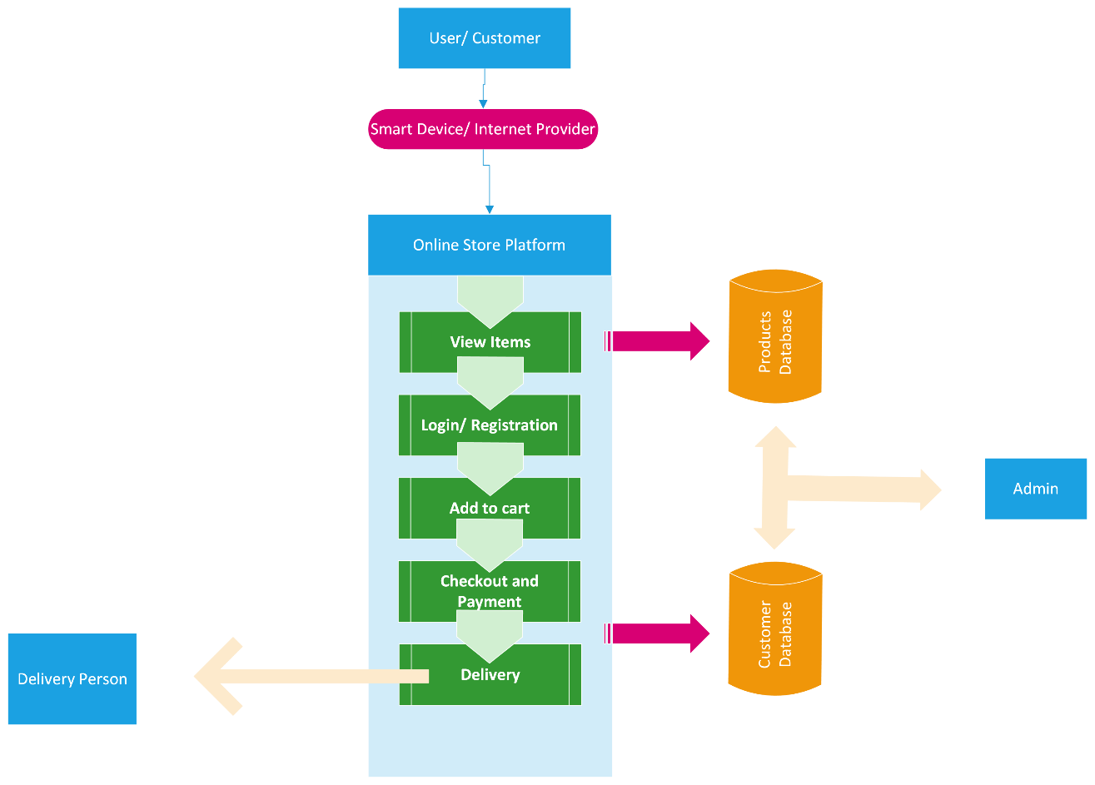

**Use-Case View**

A use case view is basically a graphical depiction of a user's possible interactions with system.

The online shopping system use cases are:

* Login
* Customer authentication
* View items
* Browse and view recommended items
* Add to shopping cart
* Make a purchase
* Checkout and make payment
* Delivery

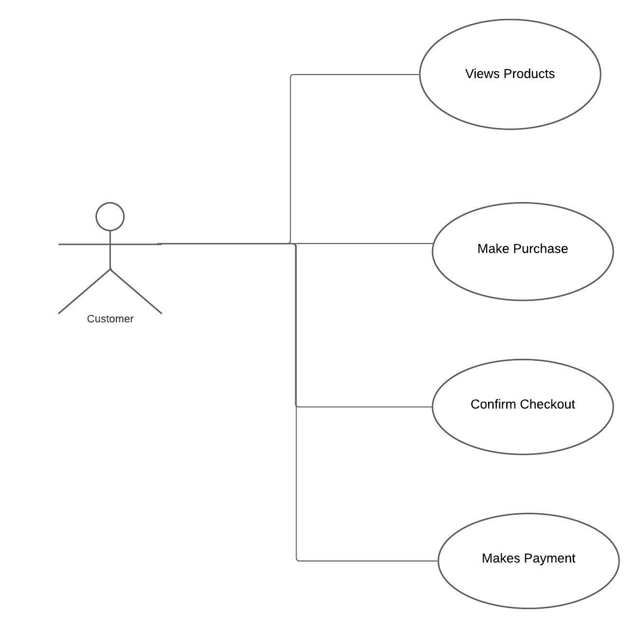

Admin

* View pending and completed orders
* Update inventory
* Manage users

Delivery person

* Views completed order
* Views customers picku-up address
* Delivers to customer

**6.****Process View**

A description of the process view of the architecture. Describes the tasks (processes and threads) involved in the system's execution, their interactions and configurations. Also describes the allocation of objects and classes to tasks.

The Process Model illustrates the viewing of products and making purchase to the delivery point.

Pseudo code

Step 1: Display Main Menu{

1: Search Product {Jump to step 2}

2: Add Product to cart {Jump to step 3}

3: Delete product from cart {Jump to step 4}

4: Move to cart {Jump to step 5}

5: Checkout{Jump to step 6}

}

Step 2: {

Enter name of the Product(input text: p_name) || Enter product ID(input text: p_id)

if(p_name || p_id.available){

Print(Product page)

}

else{

Print("Such product is not available")

}

}

Step 3: {Declare character ( ans )

Declare integer:( p_quantity = 0 )

Declare integer:( Bill )

Declare Array : product_list

Enter produtname(input text: p_name) || enter product ID(p_id)

if(p_name || p_id,is available){

Print(Product page)

Print(Product prize: p_prize)

Print("Do you want to buy this product (Y/N)")

Input character(ans)

if(ans=Y||y){

print("How many ")

Input number p_qunatity

Bill = Bill + (p_prize*p_quantity)

product_list = product_list + p_name

}

}

break;

}

Step 4: {

Print("Which product you want to remove?")

Input text(p_name)

Bill = Bill - (p_prize*p_quantity)

Product_list = product_list - p_name

break;

}

Step 5:{

Declare character c

Display cart

Print("Totatl Products")

for loop(int i=0 to i<length of product_list){

print(p_name[i] +" - "+p_prize[i] +" - "+p_quantity[i])

}

Print("Press C to checkout")

Print("Press M for main menu")

Input character:c

if(c='C' OR c= 'c'){

Jump to step 6

}

else if(c='M' OR c='m'){

Jump to step 1

}

else{

Print("Wrong Input")

break;

}

}

Step 6: {

Declare character r

Print("Final bill amount = " + Bill)

for(int j =0 to j<length of product_list){

Print("Total products = "p_name[i])

}

Print("Do you want to buy all of these products (Y/N)")

Input character: r

if(r='y' || r='Y'){

Move to payment Page

}

else if (r='n' || r='N'){

Jump to Sep 1

}

else{

print("Wrong input")

Jump to Step 1

}

}